Classification of Credit Card Defaulter and Risk Prediction

Maliha Rahman1, Iftekharul Mobin1, Md. Rezyuan1 and Kaniz Fatema1
1 Department of Computer Science and Engineering, BRAC University, 66 Mohakhali,
Dhaka 1212, Bangladesh
{maliha.rahman.tonny, iftekhar.mobin, rjnabil1994 and kaniz.vnc13}@gmail.com

Abstract—The use of credit card for a secure balance transfer is indispensable. Before giving a credit loan to borrowers, bank should decide whether borrower could be a defaulter or non-defaulter. The prediction of borrower status in future for defaulter or non-defaulter is a challenging task for bank. Loan defaulter prediction is a binary classification problem. In this paper we are comparing predictive accuracy of the customer’s default payment using three different algorithms (Naïve Bayes Classifier Algorithm (Gaussian), Logistic Regression and Decision Tree). We are going to create a model and use that model to predict who could be a defaulter in the future or having greater risk of being a defaulter. The results of this paper will indicate that the logistic regression performs best in predicting the default of credit card clients and shows the highest recall value.
Keywords—credit card defaulter; prediction; dataset

Introduction

Data analytics has become pivotal in many fields. They have decreased the dependence of man power and also remove manual errors in manipulating the data. The analytics of different classifying algorithms does help future research in this field. First hand implementations of these algorithms would also be aided by analysis of the algorithms. Applications of these algorithms on full scale implementation are cost effective, less error-prone and less time consuming [16]. An application in data analytics algorithm in banking sector is gaining momentum.it requires more research and exploration.it is high potential to cater to diversifying needs in the banking sector.

In banking Industry, credit card is a customer-oriented product which can bring profit for the bank for a longer period of time or occurrences of loss. There are some machine learning techniques which can be applied to solve credit card fraudulent problems such as: card defaulter prediction, misuse of credit cards, unauthorized access control, fraud transactions etc.

Data mining is the process of organizing through large data sets to identify problem patterns and establish relationships to solve problems through data analysis [1]. The use of data mining in banking sector has been on constant increase. Machine learning involves the usage of many classification algorithms, which is used to separate the data into many suggested number of categories. Data mining algorithms are widely used for feature selection, classification, clustering, prediction and rule framing [2]. We have used a dataset of credit card defaulter prediction from Kaggle websites. Using different algorithms of machine learning techniques defaulter and non-defaulters are predicted in this research.

The rest of the paper is about the literature review of this project (section 2), dataset and system design (section 3), methodology (section 4), the result from our project (section 5), monitored by the discussion (section 6) and conclusion (section 7).

literature review

There has been some strong research work on credit card default dataset. Abbas Keramati et.al [3] has done a literature survey on work that has been done on similar dataset. It does not extensively analyze any classification algorithm or effects of feature selection. On another paper, Adela Ioana TUDOR et.al [4] dealt with clustering analysis on a similar dataset. In the above work, data is clustered relating to similarity among different attributes present. It does not evaluate or execute any classification algorithm or feature selection. They do not represent the change in efficiency of these algorithms with respect to feature selection. Moreover, relative learning on the classifier’s performance is done by Ajey et al. to predict credit cards defaulter. In this paper, the performance of data mining algorithms, name as Bayes Net, Meta-Stacking, Random Forest, Naïve Bayes, SMO and Zero R is being discussed [5].

In our paper we have use three different algorithms to predict credit card default. As mentioned before, in previous works either it only predicts defaulter and non-defaulter or showed the best algorithm for prediction. But we have tried to improve the existing algorithm with low CPU use which can give the better Recall value (the proportion of the actual defaulters that the model will correctly predict).

Dataset And System Design

3.1 System Design

The block diagram of our system is shown in the next part (Figure 1):

Training Data
Data
Visualization
Data
Preparation

Building Models using all features
Model Analysis
(Gaussian, Logistic Regression and Decision Trees)
Performance evaluation

Recall
Precision
Accuracy

Best Algorithm
With highest Recall value

Figure 1: System Design

Dataset and Description

The dataset is obtained from “Kaggle” website. Credit default is not being able to repay or not repaying the debt. This dataset includes 25 attributes of which 24 are features and 1 is a class attribute. With 30000 instances it gives an in depth data view on the subject [6]. The processing performed on this dataset is discussed below.

Table 1: Description of the Attributes
No | Attribute Name | Description
1 | ID | User ID
2 | Limit_Bal | Amount of the given credit(NT dollar)
3 | Sex | Gender(1=male, 2=female))
4 | Education | Education  (1=graduateschool; 2=university; 3=high school;  4= others)
5 | Marriage | Marital status  (1=married; 2= single; 3= others)
6 | Age | Age (year)
7 | Pay_0 | the repayment status in September,2005
8 | Pay_2 | the repayment status in August,2005
9 | Pay_3 | the repayment status in July,2005
10 | Pay_4 | the repayment status in June,2005
11 | Pay_5 | the repayment status in May,2005
12 | Pay_6 | the repayment status in April,2005
13 | Bill_Amt1 | amount of bill statement in September,2005
14 | Bill_Amt2 | amount of bill statement in August,2005
15 | Bill_Amt3 | amount of bill statement in July,2005
16 | Bill_Amt4 | amount of bill statement in June,2005
17 | Bill_Amt5 | amount of bill statement in May,2005
18 | Bill_Amt6 | amount of bill statement in April,2005
19 | Pay_Amt1 | amount paid in September, 2005
20 | Pay_Amt2 | amount paid in August, 2005
21 | Pay_Amt3 | amount paid in July, 2005
22 | Pay_Amt4 | amount paid in June, 2005
23 | Pay_Amt5 | amount paid in May, 2005
24 | Pay_Amt6 | amount paid in April, 2005
25 | Default_Paymen  t_Next_Month | Amount to be paid next month

  - Library
We have used four libraries in this project. Numpy, Matplotlib, Pandas, Sklearn are the mostly used library in python. First of all, NumPy is the fundamental package for scientific computing with Python. It contains a powerful N-dimensional array object [7]. Secondly, Python has long been great for data mugging and preparation, but less so for data analysis and modeling. Pandas help fill this gap, enabling you to carry out your entire data analysis workflow in Python [8]. Another library is MatplotLib which is used for plotting the dataset. Lastly, Scikit-learn is a free software machine learning library for the Python programming language. It features various classification, regression and clustering algorithms [9].

3.3 Null Model and Scaling
In classification we have used a Null Model which is useful as a base or bench mark for how good our model must be. Here, null model is the simplest model and can predict the most common category. Moreover, we have imported Robust scale from scikit learn preprocessing. As many of the features have different scale, it is recommended to use some sort of scaling, in this case we are using Robust scale. This object will set all the variables in the same scale. For instance, the limit balance varies in thousands where age goes from 20 to 80 years old.

4. Methodology
There are many machine learning available as this field has increasingly gained more popularity. Machine learning algorithms can be divided into 3 broad categories — supervised learning, unsupervised learning, and reinforcement learning. Supervised learning is useful in cases where a property is available for a certain dataset (training set) but is missing and needs to be predicted for other instances [10]. In supervised learning there are many algorithms which are being used in prediction, classification problems. In this paper we have used three powerful supervised algorithms which are- Naïve Bayes (Gaussian), Logistic Regression and Decision Trees.

Naïve Bayes
The algorithm of Naïve Bayes is a simplest probabilistic classifier. The algorithm of Naïve Bayes calculates the set of probabilities by measuring the occurrence and counting the group of values in given specified data-set. However, this algorithm performs very well and learns quickly in different supervised classification problem [11].
Moreover, a class's prior may be considered by calculating an estimate for the class probability from the training set. To estimate the parameters for a feature's distribution, one must assume a distribution or generate nonparametric models for the features from the training set.

Gaussian Naive Bayes:
Additionally, when dealing with continuous data, a typical assumption is that the continuous values associated with each class are distributed according to a Gaussian distribution. [11]
- Moreover, we have imported GaussianNB from Scikit Leans Naïve Bayes Model. In addition we have created an instance of the model and trained it to evaluate the model with three scores which are accuracy, precision and recall.

Logistic Regression
Logistic regression is the appropriate regression analysis to conduct when the dependent variable is binary. Similar to all regression analyses, the logistic regression is a predictive analysis. Logistic regression is used to describe data and to explain the relationship between one dependent binary variable and one or more nominal, ordinal, interval or ratio-level independent variables [12].
Furthermore, we have imported LogiticRegression from Scikit Leans Linear Model. Then we created an instance of the estimator which passes only simple parameter not hyper parameter. The parameters are random states which indicates reproducibility and another one is “n_jobs= -1” which is a way to say the scikit learn to use all the cores that are available in the machine. Afterward, we used the fit method to train the estimator using our training data. After training the model we have evaluate with the three scores.

Decision Trees
Decision tree methodology is a commonly used data mining method for establishing classification systems based on multiple covariates or for developing prediction algorithms for a target variable.
The most important feature of DTC's is their capability to break down a complex decision-making process into a collection of simpler decisions, thus providing a solution which is often easier to interpret. When the sample size is large enough, study data can be divided into training and validation datasets. Using the training dataset to build a decision tree model and a validation dataset to decide on the appropriate tree size needed to achieve the optimal final model [13].
Likewise, we have imported Decision Tree Classifier from Scikit Leans Tree Model. Formerly we created an instance of the estimator which passes hyper parameter which are random states that indicates reproducibility, minimum number of observation that must be in a decision node to be able to split and the last one is minimum number of samples that must be in a leaf node. Later again, we utilized the fit technique to prepare the estimator utilizing our preparation information and evaluate with the three scores.

  - Performance Evaluation
Performance evaluation is a major step. It highlights the progress of algorithms. In this experiment, Algorithm’s performance is evaluated by Correct Classification (Accuracy), Precision (Positive predictive value) and Recall (Sensitivity). Accuracy shows overall how often the model predicts defaulter and non-defaulters. Precision indicated when the model predicts default, how often that is correct. Last of all Recall shows the proportion of actual defaulters that the model will predict. When three algorithms are applied to this data-set, the result of these algorithms in the form of Accuracy, Precision, and Recall are analyzed in the next part of the paper.

5. Result analysis

It is mentioned above that we are using logistic regression, classification tree and naïve Bayes model. Therefore, we used these three models in our data set. We can see the results and after analyzing the result we can see that for recall in logistic regression we can get percentage like 32%, for classification tree it is be around 36% and for the last model naïve Bayes we get 55%. We can see the graphical representation Figure 2 below:

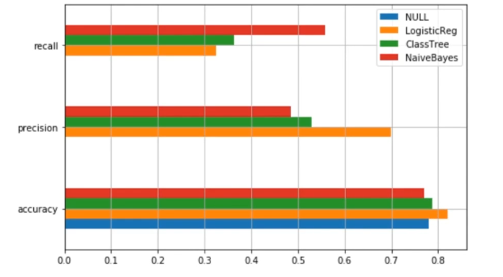
Figure 2: Performance evaluation of Algorithms

Here we can find that for recall naïve Bayes is far better than any other model. Furthermore, for precision and accuracy we can see that logistic regression is a better model. But here we are more concerned about recall as recall shows the proportion of actual defaulters and we want to develop other model which can give us a better result. So now we are going to represent another graphical representation between precision and recall.

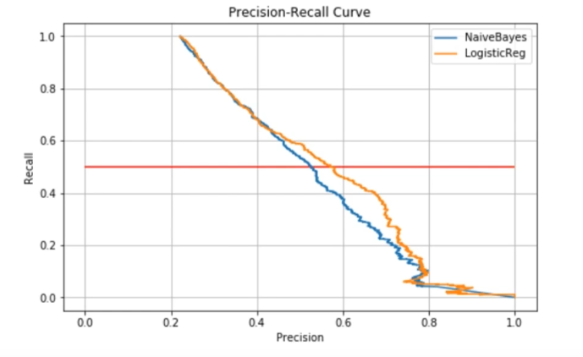
Figure 3: Precision-Recall Curve

At this point, in X-axis there is precision and in Y-axis there is recall. For a level of threshold like 0.5, from the figure 4 we can see that logistic regression model is a better model than naïve Bayes model.

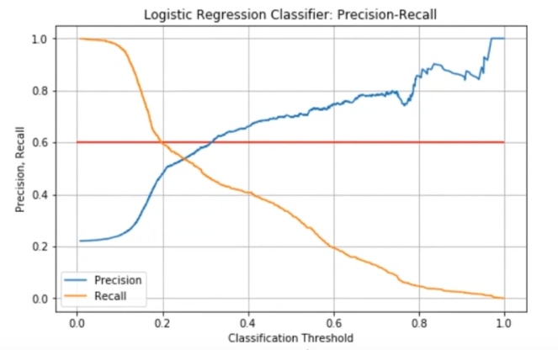
Figure 4: Logistic Regression Classifier: Precision-Recall

So if we see the final step, a graphical representation between precision recall and classification threshold we can see the mentioned figure. So for a level of threshold like 0.2 we can get precision for about 50% and for recall we will get 60%. So we can say that logistic regression has become a better model for our project. Finally, after using logistic regression in our data set we found results which are shown in figure 5 resembling Recall 59% and precision about 47%.

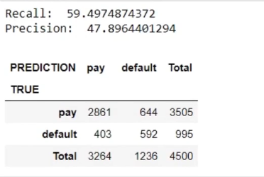
Figure 5: Final Result

6. discussion

In this project our area of work is supervised and it is mainly on classification and prediction. The area we have covered in supervision is data analytics. There are some previous works on credit card default prediction which are based on data mining [14]. There are several algorithms to get these predictions but they are time consuming and it uses a high level of CPU utilization but in data analytics it does not a great deal with CPU utilization. In data mining it will take great effort to calculate the prediction but we are using library from python to complete our project which will give outputs very fast [15]. After that we have improved a model which will give almost correct result in defaulter prediction. Without comparing results from different models if we can build a good model it will be helpful for getting the actual results very quickly.so we can say that using data analytics if we use logistic regression we will get a good result in terms of recall [15]. Moreover, we are mainly focusing on recall, so data analytics would be a great platform for the bank to predict whether a customer will default or not.

7. conclusion

Logistic regression, classification trees and naïve Bayes algorithms have classified in the dataset to good accuracy and recall thus achieving the objective of this study.

8. references

- (n.d.). Data Mining, Available: http://searchsqlserver.techtarget.com/definition/data-mining
- Jerrin, J. et al., International Journal of Research in IT, Management and Engineering, ISSN 2249-1619, Impact Factor: 6.123, Volume 07 Issue 03, March 2017, Page-14-18
- Kerama, A. and Yousefi, N. “ A Proposed Classification of Data Mining Techniques in Credit Scoring”. Proceedings of the 2011,International con ference on industrial engineering and Operations management Kuala Lumpur, Malaysia.
- Tudor, Ioana, A., Bara, A. and Andrei, E. "Clustering analysis for credit default probabilities in a retail bank portfolio." Bucharest Acad Econ Stud, Database Syst J 3 (2012): 23-30.
- Venkatesh, A. and Gracia, S. “ Prediction of Credit-Card Defaulters: A Comparative Study on Performance of sClassifiers”, International Journal of Computer Applications (0975 – 8887), Volume 145 – No.7, July 2016
- (n.d.). “credit_card_default”, Retrieve from: https://www.kaggle.com/hitz02/credit-card-default/data
- (n.d.). Numpy, Available: http://www.numpy.org/
- (n.d.). Python Data Analysis Library, Available: https://pandas.pydata.org/
- (n.d.). Scikit-learn, Retrieve from: https://en.wikipedia.org/wiki/Scikit-learn
- James, L. “The 10 Algorithms Machine Learning Engineers Need to Know”. Retreive from: https://www.kdnuggets.com/2016/08/10-algorithms-machine-learning-engineers.html
- Patil, Tina R., and S. S. Sherekar. "Performance analysis of Naive Bayes and J48 classification algorithm for data classification." International Journal of Computer Science and Applications 6.2 (2013): 256-261.
- (n.d.). Statistics Solution, Available: https://www.statisticssolutions.com/what-is-logistic-regression/
- Song, Yan-Yan & Lu, Ying. (2015). Decision tree methods: applications for classification and prediction. Shanghai archives of psychiatry. 27. 130-5. 10.11919/j.issn.1002-0829.215044.
- (n.d.). CREDIT CARD DEFAULT PREDICTION prezi.com, Retrieve from: https://prezi.com/utgdznz2avnq/credit-card-default-prediction/
- Peter Burns 2001 Managing Consumer Credit Risk SSRN Electronic Journal
- Lopes, P. year published: 2008, Article title : Credit Card Debt and Default over the Life Cycle journal title: journal of Money, Credit and Banking issue no: 4 Volume no: 40 pages: 769-790

